PRT 3520  Risk Management Plan | April 23  2014
Jessica Nebeker

Table of Contents

Section 1: Agency Description, pg 2
Section 2: Risk Identification, pg 4
Section 3: Risk Evaluation, pg 6
Section 4: Case Precedent, pg 8
Section 5: Risk Treatment, pg 12
Works Cited, pg 14

Section 1: Agency Description- Haunted House Attraction
__________________________________________________________________

Camp Kumbayahh! is a business I would love to open if I ever have the financial means and technical support to back it. It will be the first fully interactive haunted house where participants will have the choice to actually spend the night. The company combines the scare of a traditional haunted house attraction with the thrill and challenge of a scenario (i.e. murder mystery dinners). It will also include aspects of the hospitality industry with limited food and beverage service, and overnight lodging. Customers will not only be able to enjoy a walk-through scare, but see if they would survive their favorite horror film scenario. Because this company has so many components, there are several aspects of risk involved. Therefore, it is very important to look realistically at the potential liabilities it may encounter to determine if the business is feasible.
The first attraction will be located in a wooded area to incorporate the camp environment. Participants will sleep in tents or cabins, depending on the chosen package. Guests can choose an all-interactive package where anything can happen at any time, or a time-out package where a participant can designate certain times as safe zones (sleeping, meals, etc). The location of the company should give the participants a feeling of isolation and seclusion to have a more realistic experience. Because of this, it is especially important that proper medical staff is on premise to deal with any injuries, and that staff is properly trained to deal with emergencies.
Camp Kumbayahh! will incorporate several aspects of the hospitality industry in addition to being a haunted house attraction. Breakfast and dinner will be provided for customers, so the business will need a restaurant license with employees who have food handler permits. There will also be an aspect of lodging since guests will at least spend one night on the premise. The combination of food and lodging requires extra attention to sanitation and cleaning since there are higher expectations in these types of zoning.
The goal of the company is to create realistic scenarios of horror for participants. Participants should be able to answer the question “would I survive a horror movie?” Camp Kumbayahh! will give the participant the idea of what an alien invasion, zombie apocalypse, or monster attack would be like. The company will maintain safety while providing a perceived extreme environment that tests the participants’ ability to survive. It will be a memorable experience that could potentially change the haunted house industry.

Section 2: Risk Identification
__________________________________________________________________

As mentioned above, because of the extreme nature of the attraction, and the level of interaction between participants and staff, this is a very high-risk attraction. It is important to properly identify, and then minimize as many risks as possible without hurting the experience of the customer.

Risk: Injury caused by participant reactions
Participants can injure themselves and others while scared. They are not functioning with a regular ability to process decisions. The possibilities of injury include slip and fall, as well as more serious injuries caused by participants running into props and/or staff members. Injuries caused directly by participants’ reactions are a risk to the company.
Risk: Injury caused by participant interaction with natural environment
Being located in the woods increase the chances of human-animal interaction, and participants must understand the risk of such interactions and what to do in that circumstance. Such risks could be as minimal as animals getting into garbage, a skunk spray, or as severe as a bear attack. It is also worth noting that participants may encounter the risks of car accidents involving wildlife before they even arrive at the attraction. On a further note, because the natural environment is full of tripping hazards (roots, uneven footing, poor lighting, etc.).
Risk: Injury caused by actions of staff members
Because of the interaction between staff in a haunted house and the participants , it is a definite possibility that participants could be injured by actions of the staff. Examples of risk include objects thrown by the staff, physical contact by staff members, and food illnesses caused by improper handling of food for meals.
Risk: Building condition
It is important to keep up on the physical condition of the building. A dilapidated building can cause injury by creating a hazardous condition. Therefore it is important to make sure maintenance is upkept on any issues- cracked surfaces, mold, etc. Building codes must be kept up on and any inspections must be passed.
Risk: Bankruptcy
Bankruptcy is a major concern if the company runs into any financial problems. If the company has to unexpectedly make repairs or shut down for a time, it can be detrimental to the company’s finances.

Section 3: Risk Evaluation
__________________________________________________________________

Although the list of potential risks could be endless, an agency does not necessarily have to needlessly stress daily over certain liabilities. This is because risks vary in frequency and severity. Although the frequency of someone stubbing their toe or slipping may be higher, it is unlikely that it would be fatal. On the opposite end of the spectrum, someone suffering from a bear attack could be very severe and possibly even end in death, but the scenario is much less frequent. It is because of these considerations that an agency must evaluate all potential risks it may encounter to determine which ones are the highest priority and deserve the most attention. It is impossible to protect against all risk, and it is certainly impossible to completely protect participants without harming the experience. As mentioned in class, life would not be fun without a little risk.

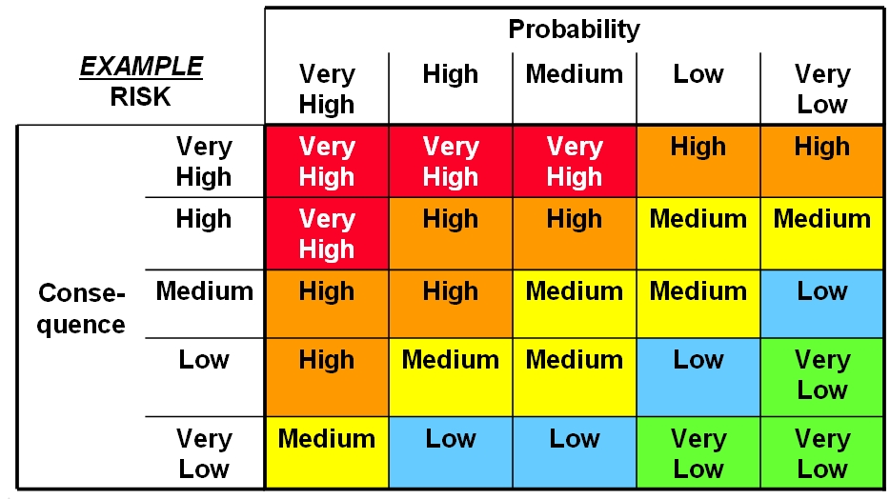

Risk 1: Injury caused by negative reaction to scare
Frequency: The frequency of such injuries could be quite frequent. Participants could trip on props, run into walls and other guests.
Severity: As will be shown with its case precedent, injuries can range from a simple stubbing of the toe, minor scrape, broken nose from running into a wall, or potentially as severe as a broken bone if the person falls wrong.
- Because of the combination of the fairly frequent but non-fatal severity, I would categorize the risk of this type of injury as a low or medium risk.
Risk 2: Injury to participant from actions of staff
Frequency: The probability of such injuries should be low to medium, since staff should be properly trained and not interacting with participants in a dangerous manner. However, because of the increased interaction between the staff of Camp Kumbayahh! and the participants, it is more likely that an injury will occur than in a normal haunted house.
Severity: injuries can range from minor bruises to the more extreme cases of impact trauma causing spinal and head injuries
- These types of injury are relatively frequent but range in severity. The most common instances of such injury should be fairly inconsequential, but because of the range, will be considered a medium-high risk.
Risk 3: Complications of bankruptcy and building code failure
Frequency: The probability should hopefully be low, but unexpected things happen that can put the company at risk
Severity: Bankruptcy is one of the most severe risks of a business, and should be taken extremely seriously.
- While the probability of bankruptcy should be relatively low, the consequences of such a risk are extremely high. Therefore, this risk will be considered high to very high.
Section 4: Case Precedent
__________________________________________________________________

- Injury caused by actions of participant
- Injury caused by participant running into structure in reaction to scare.
In the case of Mays v. Gretna Athletic Boosters Inc, the plaintiff sued the defendant for injuries suffered when she ran into a cinder block wall at their haunted house. Gretna Athletic Boosters Inc. held a fund raiser haunted house on a playground every year to pay for athletic programs. This haunted house was a temporary structure made by 2x4s and black visqueen. Near the end of the haunted house was a cinderblock bathroom that was covered in the black visqueen for the haunted house. When the plaintiff got scared, she ran straight into the cinderblock wall of the bathrooms. She split her nose open in the impact, claiming it took two surgeries to fix it.
The court found that the defendant was not liable. GAB provided adequate staff to supervise participants, and the rooms were large enough to accommodate walking. The court also ruled that because being frightened was the expected reaction of participants that was willingly accepted by entering, the defendant had no duty to protect the plaintiff from such reactions.
This case shows the importance of following regulations. If the GAB had not provided proper supervision or cut corners with room construction, they may not have been as lucky. The goal of a haunted house is to create a reaction from its customers, but it is also important to minimize the unnecessary risks.
- Injury caused by falling down in fright while exiting attraction
Galan v. Covenant House New Orleans. The plaintiff sued the haunted house when she fell down in the exit of the attraction after being scared by a last-minute fright. The issue in this claim was over the unexpected appearance of the actor, when the participant thought the haunted house was done. The court found that the defendant was not liable, again saying that the attraction provided adequate supervision and owed the plaintiff no duty in protection since the “unexpected” was expected at the haunted house.
- Injury suffered from actions of staff member- hit in head by object
The case of Powell v. Jacor Communications Corporate involves a plaintiff suing Jacor when she was hit in the head with an unidentified object while participating in their haunted house. Ms. Powell claims she was knocked unconscious and suffered a concussion when she was hit by something she said was thrown by a staff member dressed as a ghost. She received treatment from the emergency room physicians, but claimed severe neuropsychological disorders as a result of the incident.
This case was thrown out by the court due to statute of limitations. The statute of limitations in Kentucky for a case like this is one year. The incident occurred in 1999, and the plaintiff filed just two days before the cutoff in 2000. Because the courts required a screening process, the summons was not sent immediately after filing. It was not until December of 2000 that Jacor received a summons. This created the viable defense for statute of limitations.
The case proves the importance of documentation and deadlines. If any incident occurs, it is in the company’s best interest to document the accident with the specific information of when the incident occurred, what happened, and what actions were taken as a result.
- Issues involving bankruptcy and business being shut down for building condition
The case of Spookyworld v. Town of Berlin is a case of a company against a town. Spookyworld opened on a leased land in Berlin, Massachusetts. The issue arose when a town inspector failed two of the attraction’s building due to a violation in fire code. The inspector ruled that the company would have to shut down unless they updated the buildings with sprinklers. Spookyworld contended this because it was only open one month of the year and argued they would lose too much business by being shut down for the crucial month of October in order to install sprinkler systems. The company originally tried to negotiate with the town to create a temporary solution that would allow them to avoid shutting down. The negotiations fell through and the situation escalated.
The town filed a complaint against Spookyworld asking for a temporary restraining order that would shut the business down. The town sought a fine for each day the company did not comply; the court issued this restraining order within a day of the request. The next day Spookyworld filed for Chapter 11 Bankruptcy. Under the current statute they would have been allowed to continue operating the attractions under the automatic stay provision. Unfortunately they still shut down because town officials threatened employees with arrest for non-compliance of the court’s mandate.
There were several more court hearings and complications, but the town ended up winning.
This case shows the importance of a good relationship with the surrounding community. While it is still important to maintain building codes and make sure conditions are safe for participant, if Spookyworld had not had influential members of Berlin working against it, the owners may have been able to put repairs off until after the season rather than filing for bankruptcy. In the case of Camp Kumbayahh! it will be important to make sure building codes are up to standard and create a good relationship with any neighbors.

Section 5: Risk Treatment
__________________________________________________________________

Risk 1: Injury caused by participant’s reaction to fear.
While it is impossible to completely predict the actions of all participants and entirely prevent all risk, there are certain steps the company can take to minimize these risks
Treatment:
- Retain and reduce the low-medium injuries by making sure walkways are clear and there are no tripping hazards or anything people could get cut on.
- Any raised surfaces should be marked with tape, wet surfaces marked with a sign, and outdoor areas properly lit.
- Participants will be briefed on safety procedures and wildlife
- There will be a first-aid station on premise with a certified EMT to care for any injury until paramedics arrived for serious injuries.
- It will also be a necessity to get insurance to transfer any remaining risk, and to have all participants sign a well-worded waiver.
- Because of the increased risk of the activity, all participants must be at least 18 years old so the waiver will hold in court
Risk 2: Injury caused by staff
Because the employer is held liable for any actions of an employee while performing his/her job, this is a risk the company will have to take quite seriously. The staff will be very interactive and potentially physical with participants.
Treatment:
- Part of the risk will be transferred through insurance, but all staff members should be thoroughly trained about what is acceptable to avoid this risk.
- Also, such injuries should be avoided by ensuring any interactive props are not dangerous to participants (soft, well padded, etc.).
Risk 3: Bankruptcy and building code failure
While this risk is rare, the severity is extreme.
Treatment:
- Good insurance should help transfer some of the risk, but the goal would be to completely avoid or close this risk.
- All building codes should be reviewed during construction and before opening.
- It would also be a good idea to keep a decent nest-egg of savings in case of unexpected repairs or shutdowns during peak season.

Works Cited
Galan v. Covenant House New Orleans. 695 So.2d 1007. (1997). Retrieved from http://scholar.google.com/scholar_case?case=2442667261700723309&q=%22haunted+h ouse%22&hl=en&as_sdt=6,45
Kimbar v. Estis. 1 N.Y.2d 399. (1956). Retrieved from http://scholar.google.com/scholar_case?case=5946336510001630532&q=summer+camp &hl=en&as_sdt=6,45
Mays v. Gretna Athletic Boosters, Inc. 668 So.2d 1207. (1996). Retrieved from http://scholar.google.com/scholar_case?case=7842299894782293434&q=%22haunted+h ouse%22&hl=en&as_sdt=6,45
Powell v. Jacor Communications Corporate. 320 F.3d 599. (2003). Retrieved from http://scholar.google.com/scholar_case?case=17772600045687925564&q=%22haunted+ house%22&hl=en&as_sdt=6,45
Spookyworld v. Town of Berlin. 346 F.3d 1. (2003). Retrieved from http://scholar.google.com/scholar_case?case=15936854178362875967&q=%22haunted+ house%22&hl=en&as_sdt=6,45

